

Topical Meeting of the ANS Nuclear Criticality Safety Division

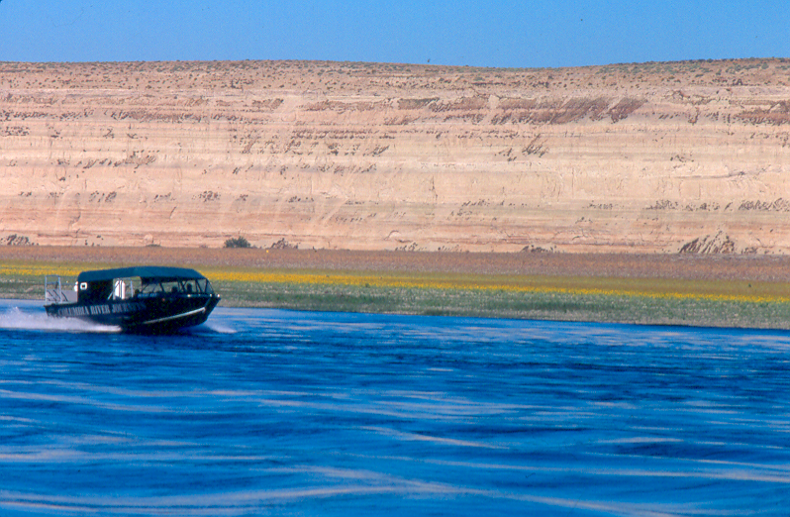
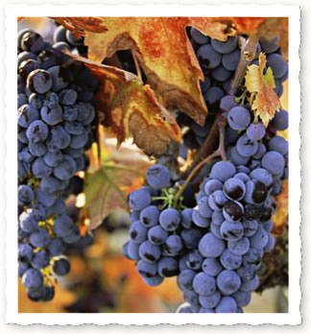
Nuclear Criticality Safety: Realism, Robustness and the Nuclear Renaissance

Riverside Shilo Inn
Richland, Washington USA
September 13-17, 2009

The technical program will consist of invited plenary, panel sessions and focused in-depth technical sessions. The sessions will be organized along specific areas of technical interest listed below.
REVISED SCHEDULE for AUTHORS:

January 23, 2009 Electronic submission of 400 word summaries
February 23, 2009 Notification to authors
May 1, 2009 Submission of full papers
June 12, 2009 Final notification to authors
July 10, 2009 Full papers due for publication (CD)

To submit an abstract and find additional information, please visit us at www.ncsd2009.com including info about the

STUDENT PAPER COMPETITION!!!!

Realism and Criticality Safety:
- Critical Experiments
- Modeling Assumptions
- Accident scenarios
- Safety Margin
- Industry Lessons Learned
- Nuclear Data and Benchmark Selection

Robustness in Controls:
- Development of Criticality Controls
- Requirements and Standards role
- Implementation of Criticality Controls
- Double Contingency
- International experience
- New 10CFR70 Subpart H

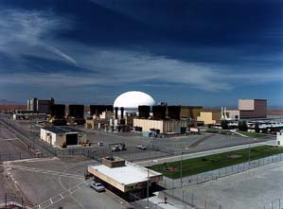
Ready for the Renaissance:
- Status and scope of GNEP and New
Enrichment Facilities
- Criticality safety needs for the fuel cycle (enrichment, fabrication, transportation, storage and disposal)
- Harvesting existing benchmark data (fuel cycle and nuclear data)
- In-situ measurements
- Criticality safety and engineering design
- Use of computerized control systems
- People needs, training and education
  - Invited Panel Session: ARE WE READY?

Invited/Keynote Speakers include: Chip Lagdon (US DOE, Chief of Nuclear Safety), Andy Cook (Sr. VP, Areva North American Nuclear Power), and David Ayres (NRC)

Technical Tours:
•B Reactor • FFTF (Fast Flux Test Facility) • LIGO Hanford Observatory • Areva NP Facility •

Embedded Workshops/Tutorials:

Sunday, September 13:
SCALE 6: KENO - 3-D multigroup/continuous-energy Monte Carlo criticality safety code
SCALE 6: TSUNAMI – Tools for Sensitivity and Uncertainty Analysis Methodology Implementation
(http://www.ornl.gov/sci/scale/ )
Thursday, September 17:
Visual Editor for MCNP - Graphical user interface for efficient creation and interrogation of input files for MCNP (http://www.mcnpvised.com/ )
DICE –Database for the International Handbook of Evaluated Criticality Safety Benchmark Experiments. (www.nea.fr/html/science/wpncs/icsbep/)

NCSD2009 Organizing Committee:
General Chairman:
Michaele Brady Raap
michaele.bradyraap@pnl.gov

Publications Chairman:
Ray Puigh
Raymond_Puigh@rl.gov

Honorary Chairman:
Hans Toffer
Htoffer@aol.com

Technical Tours:
Maynard Plahuta
myplahuta@clearwire.net

Technical Program Chairman:
Calvin Manning
Calvin.Manning@areva.com

Corporate Sponsorship:
Jennifer Tanner
jennifer.tanner@pnl.gov

Finance Chairman:
Scott Finfrock
Scott.Finfrock@fluor.com

Student Coordinator:
Andrew Prichard
andrew.prichard@pnl.gov

DOE/RL Liaison:
L. (Tom) Nirider
Laurren_T_Nirider@rl.gov

Registration/Hospitality:
Dave and Dee Watrous
DavWatrous@aol.com

