THIS IS THE TEMPLATE TO WRITE A MANUSCRIPT FOR NCSD 2017 WITH MS WORD – TITLE CENTERED, 14 PT, BOLD, UPPERCASE, TIMES NEW ROMAN, SECOND LINE FROM TOP, MAX 3 LINES LONG

First A. Author, Second B. Author
Department of Nuclear Engineering
University of Whoville, West Dakota, USA
f.a.author@whoville.edu
s.b.author@whoville.edu

Blank line, Third Author with different affiliation
Nuclear Engineering Division
Florida National Laboratory, Alachua, Florida, USA
Third.Author@fnl.gov

ABSTRACT

Use US Letter paper size, top and bottom margins of 1.0 “, left and right margins of 0.9”. The abstract should be 200 – 250 words long. Leave two blank lines before the header of the “ABSTRACT”, and leave one blank line after. For the abstract, use 11 point Times New Roman and single line spacing. The abstract gives a brief summary of the work, including a justification for the work, method of research, results, and conclusions in brief. Show that your work is new and how it relates to the state-of-the-art.

Key Words: list a minimum of 3 and a maximum of 6 key words, in boldface.

1. INTRODUCTION

This is v1.0 Release Candidate 1 of the NCSD2017 template for MS Word. Your paper starts here with two blank lines, followed by the first section title. Use US Letter paper size; top and bottom margins of 1.0”; left and right margins of 0.9”. Use 12 pt Times New Roman font. Use “justified” settings (i.e. the text is border is “straight” both on the left and the right side margins). Insert an empty line before and after each subsequent section title. Section titles are all uppercase, 12 pt Times New Roman, boldface, and numbered (Acknowledgements and References sections are not numbered.

Double-check your hyphen-ation set-tings. In all cases, avoid so-called “widows and orphans”. A widow is a paragraph-ending line that falls at the beginning of the following page or column, thus separated from the rest of the text. An orphan is either a paragraph-opening line that appears by itself at the bottom of a page or column, or a (part of a) word or a very short line that appears by itself at the end of paragraph. Orphans thus result in too much white space between paragraphs or at the end of the page. Try to eliminate widows and orphans as much as possible. You can “repair” widows and orphans for example by moving figures and tables, or by shortening or lengthening a paragraph. Add blank lines at the end of a page if needed to move an opening sentence to the next page.

Name format for authors. The “natural” way to write a personal name is different from country to country. We do not enforce any strict rule. Write your name(s) in a format that feels most natural. If desired, you can emphasize your family name by writing it in ALL CAPITALS. We do not specify specific rules for hyphenation and/or interpunction in names: “Jean-Marie Leblanc”, “J.-M. Leblanc”, or “Leblanc, JM” are all equally acceptable. If there are two authors with the same affiliation, then use “Author1 and Author2”; if there are three or more authors with the same affiliation, use “Author1, Author2, …, AuthorN, and AuthorN+1”.

Address format: we do not enforce any specific format. You must enter your affiliation. A mail address is not required, but may be entered if desired. If you enter your mail address, then give sufficient details, including postal code etc. Don’t forget the name of your country.

Do not indent the first line of a paragraph; rather, use an empty line between paragraphs. References are divided into 4 categories: journal papers [1], conference papers [2], books [3], and websites [4]. References to websites are generally discouraged but acceptable if necessary. The author should make sure that any URLs included in the final PDF file work correctly (at least at the time of writing). References are numbered in the order in which they are called out in the text. In the case of two citations, use the format [1,2]; in the case of more than two citations, use a hyphen, i.e. see [2-4]. In the list of references at the end of the manuscript, if the reference has more than one author, follow the format of the reference, i.e., enter “Author1, Author2, and Author3” if the original work uses that format, or enter “Author1, Author2, Author3” if the original work has that format. Maintain the name order of the original work in the list of references.

An optimal PDF conversion will be obtained with the PDF export plug-in in MS Office, available as a free download from the MS Office website, or by printing to a PDF file. Check your final PDF and make sure that all special symbols are correctly displayed. Use “Embed all fonts” (or equivalent) settings in your PDF export if your PDF software provides such an option. The final PDF should not exceed 4 MB. Required page limit bounds are 5 to 15 pages, and the suggested length is 8 to 12 pages.

From page 2 of your manuscript the header is different from the header on the title page. On even pages (page 2, 4, 6, etc) include the names of the authors in the page header. Suggested format:
- One author: A. Author
- Two authors: A. Author & B. Author
- Three authors: A. Author, B. Author & C. Author
- More than three authors: A. Author et al.
Similar to the title page, the format of personal names is not strictly regulated. Write your name(s) in the way that seems best to you. In the case of very long names, use initials so that all information fits on one line in the header.

On the odd pages (page 3, 5, 7, etc), insert the title of your manuscript into the header. If you have a long title, make a shorter title so that it will fit in one line in the page header.

2. SECOND OR SUBSEQUENT MAJOR HEADING

Provide a logical division of your paper into sections and subsections. For a conference paper, it is recommended to use two levels of sectioning (i.e. sections and subsections) but sub-sub-sections are acceptable if necessary.

2.1. Subsection Title: First Letter of Each Non-Trivial Word is Capitalized

Leave one empty line before and after headings. Secondary titles start flush left, 12 pt Times New Roman, boldface.

2.1.1. Sub-subsection: only the first word is capitalized

Sub-subsection headings use 11 pt Times New Roman boldface. Equations are to be set centered with an equation number, if present, set flush right. If an equation exceeds one line, the equation number is to be set at “centered” height. The easiest way to control the typesetting of equation and equation numbers is to include the equation and the number in a table, see Equation (1).

$$\hat{Ω}∙∇ψ^{g}\left(r,\hat{Ω}\right)+Σ_{t}^{g}\left(r\right)=\int_{4π}{d{\hat{Ω}}^{'}\sum_{g^{'}=1}^{G}{Σ_{s}^{g^{'}→g}\left(r;{\hat{Ω}}^{'}∙\hat{Ω}\right)ψ^{g^{'}}\left(r,\hat{Ω}\right)}}+\frac{1}{4π}\frac{Χ^{g}}{k}\int_{4π}{d{\hat{Ω}}^{'}\sum_{g^{'}=1}^{G}{νΣ_{f}^{g^{'}}\left(r\right)ψ^{g^{'}}\left(r,\hat{Ω}\right)}}$$ | (1)

Do not indent after an equation. Instead, leave one blank line before and after the equation. Traditionally, equations are only given a number if there is a reference to the equation. Indeed, without a reference, there is no need for an equation number. We leave it to the author to decide whether or not to apply an equation number to all equations or only to some equations.

3. FIGURES

A picture tells a thousand words, so please feel free to use appropriate illustrations. If you include figures into your manuscript, then please take the following into account:

- All fonts in your figures should be at least 10 pt in the final PDF. You are encouraged to use Times New Roman font in figures.
- If bitmapped material is used, note that JPG is most efficiently included in the final PDF, i.e. JPG will produce the smallest PDF file.
- For bitmapped material, minimum resolution is 300x300 dpi but coarser figures are acceptable if necessary.

Leave one blank line before the figure; leave one blank line after the figure, then start the caption. Leave at least one blank line after the caption. Avoid widows and orphans. Add blank lines after a caption to fill a page if necessary. Make sure that captions are not broken over the page! Figure captions are positioned below the figure; only the word “Figure” and the figure number are boldface. Captions run over the entire width of the text. If the caption spans only one line, the caption is centered; if the caption spans several lines, it is “justified”, i.e. left- and right-adjusted. Figures must be referenced in the text; if a figure is not referenced in the text, it should be deleted from the manuscript.

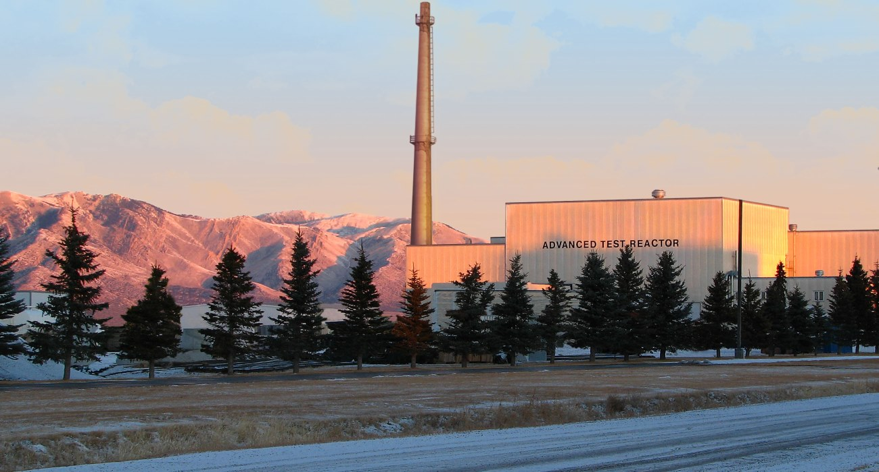

Figure 1. Figures are centered on the page. After the figure, leave one blank line, then start the caption. Captions run over the entire width of the page in normal font size (12 pt Times New Roman). If the caption spans one line, then it is centered; if the caption spans several lines, then it is “justified”, i.e. left- and right-adjusted. This photo shows the Advanced Test Reactor at Idaho National Laboratory at sunrise.

4. TABLES

The table captions are positioned above the table. Only “Table” and the table number are boldface. Leave two blank lines between the text and the table caption. Leave one blank line between the caption and the table body. Similar to figure captions, table captions are centered if they span less than a line. If the caption spans more than one line, it is “justified”, i.e. left- and right-adjusted. The layout of the table body is not prescribed.

Table 1. Some properties of nuclear reactor coolants. Table captions are positioned above the table, and may run over the entire width of the page. Leave one blank line between caption and the body of the table

 | Water | Molten Salt | Sodium | Helium
Shiny | Nope | Nope | Most definitely! | Nope
Tasty | Umm.. | Depends | In combination with Cl | Nope
Good moderator | Yes | No | Sometimes | Only in liquid form
Makes you talk funny | No | No | No | Yes

5. CONCLUSIONS

Every paper needs a conclusion. Your conclusion is your opportunity to wrap up your paper in a tidy package and bring it home for your reader. It should also reinforce any assertions made in the introductory paragraphs. Thus, it should be manifest that if all the economists were laid end to end, they'd never reach a conclusion. Don’t not reach a conclusion.

ACKNOWLEDGMENTS

I would like to thank my sponsor, Bruce Wayne, my agent, Darth Vader, the game Tetris (for providing me with the skills to jam as many dishes as possible in my dishwasher), and my legs, for always supporting me. This template was originally written by W.F.G. van Rooijen, University of Fukui, Japan, and shamelessly plagiarized but substantially improved by M. D. DeHart, Idaho National Laboratory, USA.

REFERENCES

- B. Authors, “Title”, Journal name italic, volume(number), pp. 25 – 34. URL http://dx.doi.org/doi_number (year)
- C.D. Authors, “Title”, Proc. Int. Conf. Conference name in italic (editor name if available), Organization, location & date, vol nr, pp. 25 – 34 (year)
- E.F. Author, Book title in italic, Publisher, City, Country, (year)
- “name of website”, available online. URL http://www.website.ext/ (2013)

APPENDIX A. HOW TO MAKE AN APPENDIX

Include appendices here. Appendices are numbered alphabetically (‘A’, ‘B’, ‘C’). The appendix header follows the rule for section headers: all capital letters. If one (or more) appendices are entered, then make sure that there are corresponding references from the main text. Appendices without references in the body of the paper (“dangling” appendices) are expressly forbidden.

Footnote Times New Roman 10 pt, in running text numbered with Arabic numerals. This would be a good place to include your internet address (home page, etc) if desired: www.dne.whoville.edu

