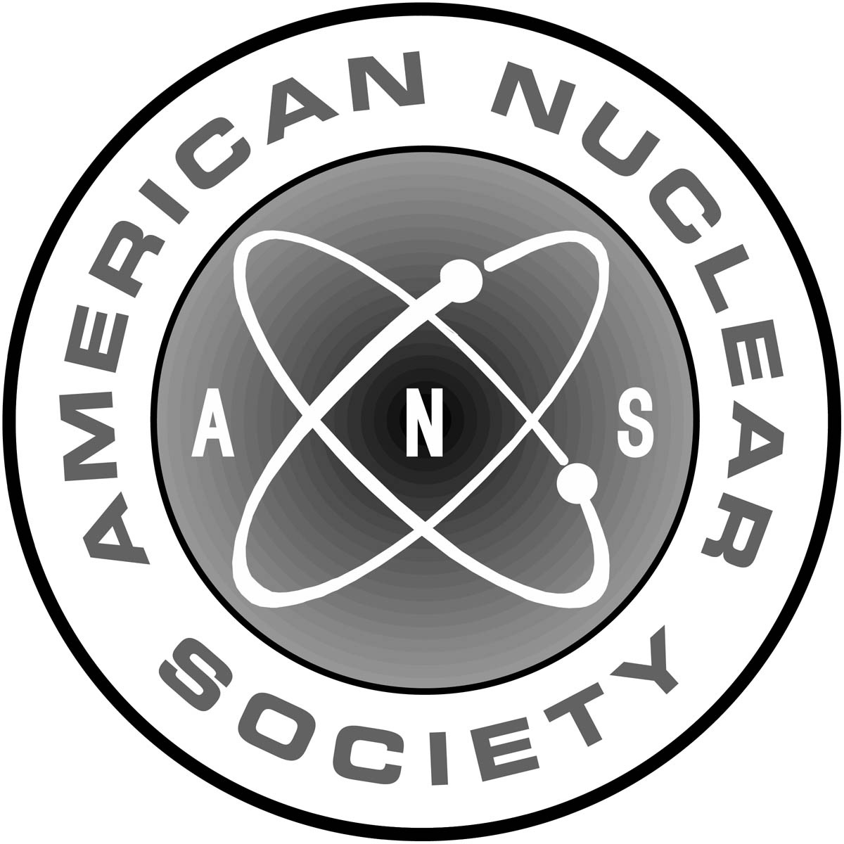AMERICAN NUCLEAR SOCIETY, 555 N. Kensington Ave., LaGrange Park, IL 60526, Fax: 708/579-8313, email: eleitschuh@ans.org

Presenter Agreement

I, _____________________________________________, a speaker at the ANS Meeting noted below,
(please print name)

willingly provide an electronic copy of the slides/presentation identified below to the American Nuclear Society. I understand that ANS will be placing this information on its website. I confirm that all artwork and proof of ownership, or permissions or assignments of copyright for quotations from text or graphic elements published or copyrighted elsewhere have been received.

I warrant that the presentation is original and that it contains no matter which is libelous, obscene or infringes upon any existing right of privacy, copyright, trademark or any other statutory or common law proprietary or civil right. I also agree to indemnify, defend and hold ANS, its directors, officers, employees and agents harmless against any claims to the contrary.

I hereby grant to ANS a perpetual, royalty free, worldwide nonexclusive license to publish the entire work in electronic versions or any other version or media now existing and/or later to be created.

In consideration of this transfer, ANS agrees to publish the presentation at its own expense. ANS has complete discretion as to where to place the presentation on its website, and reserves the right to edit the presentation according to ANS format and style according to any space constraints. I also understand that ANS reserves the right to pull the presentation from publication at any time for any reason whatsoever.

ANS Meeting:

Presentation title:

Paper No.:

Author name:

Address:

City/state/zip:

Day phone: Email:

Author signature: ___________________________________________ Date: ___________________

NOTE: Upon completion, this form can be faxed to 708/579-8313, or scanned and sent as a pdf file to the email address provided at the top of this form

