Title of the Paper Goes Here: Capitalize the First Letter of Major Words, Centered, 14-Point Times New Roman, On the Second Line from the Top Margin, Not More Than Three Lines Long

Author A¹, Author B²∗, Author C³, …, Author N^{n}
(Do not use all capital letters for any part of any author’s name)

¹Name of Institute, City, State
²Name of Institute, City, State
³Name of Institute, City, State
^{n}Name of Institute, City, State

[leave space for DOI, which will be inserted by ANS]

ABSTRACT

A required 200-250 word abstract starts on this line. Leave two blank lines before "ABSTRACT" and one after. Use 10-point Times New Roman here and single spacing. The abstract highlights the main accomplishments, what is new, and how it relates to the state-of-the-art.
Keywords: List of no more than five keywords

INTRODUCTION

Introduce the topic of the work in this section. Section titles have the style "Heading 1", are 12 point font, must be all uppercase and text justified, and must be numbered in Arabic numerals as shown above. Use 8.5" ×11" paper size, with 1" margins on all sides. Use one blank line before and after each subsequent section's title.

Do not indent the first line of a paragraph; rather add one blank line between paragraphs. Use Times New Roman font (and Symbol if needed) and font size 11 for the main body of the paper. There are four types of reference styles: journal paper [1], proceeding paper [2], book [3], and website [4]. References to websites are discouraged. It is the author’s responsibility to check links in the PDF file of the paper. All references should be cited in the text in numerical order, in order of appearance as [3-5].

The full paper should be laid out and formatted according to this template. Because the paper will be included as a .pdf file for the proceedings, the author will get the best results from Word or WordPerfect by using the Acrobat Distiller or Acrobat PDFWriter as the default printer. When creating the PDF version, check the “Embed All Fonts” option. Note that it is the author’s responsibility to review the final PDF version of the paper to ensure proper translation into PDF. Final PDF file size should be no more than 4 MB. Recommended paper length is 8-10 pages. The limit for full-paper submissions is 10 pages. If an exception is made and a paper over 10 pages is accepted, page charges are $100/page for p. 11 and above.

Do not include bookmarks or hyperlinks to references, figures, and tables in the text of your paper in your final PDF document. Do not include highlighting, page numbers, headers, or footers. Do not save your PDF as “read only.”

SECOND OR SUBSEQUENT MAJOR HEADING (FONT SIZE 12 POINT)

A logical division of the paper into sections, etc., makes it so much easier to understand. The style for subsection titles and all text in this template is “Heading 2,” “Heading 3,” etc. All text in this template is “Body Text 3.” Make sure to avoid widow/orphan lines.

2.1. Subsection Title: First Character of Each Non-trivial Word is Uppercase (12 Point)

Add a blank line before and after secondary titles. Secondary titles should start flush left and are numbered as illustrated above.

Equations should be centered and sequentially numbered to the flush right of the formula. Use Times New Roman or Euclid font with a font size 11 for the text variables and corresponding sizes proportionally for the subscripts and superscripts.

$Speedup=\frac{1}{\frac{f}{p}+(1-f)} ==$ , (1)

where $f$ and p are the variables in the equation. The equation has punctuation and the continuation of a paragraph after an equation is not indented. All paragraphs, section or subsection headings, as well as equations are separated by just one single empty line.

2.1.1. Sub-subsection level and lower: only first character uppercase (12 point)

Figures and tables should appear as closely as possible to where they are first cited, e.g., Fig. 1, in the text. Figures are numbered in Arabic numerals, with the caption centered below the figure, in boldface.

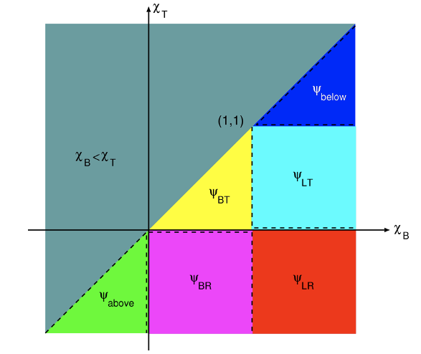

Figure 1. Sample figure. Color is permitted but must be readable if printed in gray scale.

When importing figures or any graphical image please verify two things:
- Any number, text or symbol is in Times New Roman font and is not smaller than 10 point after reduction to the actual window in the paper;
- That it can be translated into PDF.

Tables, such as Table I, are numbered in Roman numerals, with the table title in boldface centered above the table with a blank line between the title and actual table. Use two blank lines before and after the table.

Table I. Sample table: Accuracy of nodal and characteristic methods.

Mesh | 8 x 8 | 16 x 16 | 32 x 32
Nodal | 1.000 10⁻¹ | 2.500 10⁻² | 6.250 10⁻³
Characteristic | 1.000 10⁻¹ | 2.500 10⁻² | 6.250 10⁻³

Use SI Units (in parentheses, not square brackets). Conventional (non-SI) quantities may follow parenthetically if the author desires. Watch the number of significant digits.

CONCLUSIONS

Present summary and conclusions here.

NOMENCLATURE (IF NEEDED)

If variables are extensively used in the text, a Nomenclature section would be helpful to the reader.

ACKNOWLEDGMENTS

Acknowledge the help of colleagues, and sources of funding, as appropriate.

REFERENCES

- B. Author(s), “Title,” Journal Name in Italic, Volume in Bold (followed by the issue number in parentheses if known, see Ref. 5 below), pp.34-89 (2001).
- C. D. Author(s), “Article Title,” Proceedings of Meeting in Italic, Location, Dates of Meeting, Vol. 1, pp.134-156 (2017).
- E. Author, Book Title in Italic, Page or Chapter Numbers, Publisher, City & Country (2020).
- “Spallation Neutron Source: The next-generation neutron-scattering facility for the United States,” http://www.sns.gov/documentation/sns_brochure.pdf (2002).
- A. Author and G. Author, “Title,” Nuclear Technology. 146 (3), pp. 257-273 (2009).

APPENDIX A

If necessary, include Appendices numbered in upper case alphabetical order.

To ensure a uniform, professional look at the proceedings, please only modify the format of this template after checking with the organizers first.

∗ Email address for primary/corresponding author only

